**A study on driver behaviour, vehicle-related issues, and the impact of INSEE protocols on road safety and logistics operations**

Prepared By :

W. A. P. C Fernando

s16206

2021s18811

Purpose :

A report submitted in partial fulfilment of the requirement for the Service Learning of the Faculty of Science, University of Colombo

**Acknowledgements**

I would like to sincerely thank the Career Guidance Unit (CGU) of the University of Colombo for organizing and supporting this project from beginning to end. Their help and encouragement made a big difference throughout this journey.

A special thank you goes to Dr. Sameera Ariyawansa, my main academic mentor. His guidance, constructive feedback, and constant support were incredibly helpful and played a key role in completing this project successfully.

I’m also very grateful to Dr. Vindhya Kulasena and Dr. Ayomi Witharana for their academic support and mentorship. Their advice and encouragement meant a lot.

I would also like to express my appreciation to Mr. Menan Jayarathne and Mr. Saman Chathuranga Kumara from INSEE. Their industry knowledge, professional guidance, and real-world insights added great value to this experience and helped me understand the practical side of the project better.

Finally, a big thank you to my fellow group members. Your teamwork, dedication, and support made this project both successful and enjoyable.

**Table of Contents**

Executive Summary

Introduction

Methodology

Results

Discussion

Conclusions

References

Annexure

**Executive Summary**

This report is based on a study done in partnership with INSEE Cement Sri Lanka to understand the behavior of drivers, vehicle-related problems, and how INSEE’s safety protocols affect daily logistics operations. The goal was to find out what challenges the drivers face and suggested ways to improve safety, efficiency, and driver satisfaction.

The research was carried out by conducting surveys and interviews with 150 randomly selected drivers from different parts of the country. Data was collected from several INSEE locations, including Trincomalee, Galle, Kelaniya, and Puttalam. The study was focused on things like driver fatigue, vehicle maintenance, long working hours, and knowledge of safety procedures.

The results showed that most drivers work long hours, and those with longer working hours are usually less satisfied. A good work-life balance is linked to higher job satisfaction. The study also found that drivers who are more satisfied tend to report vehicle issues more responsibly. Night driving is the preferred time for most drivers due to lower traffic and better conditions, while office and school times are considered the most stressful periods to drive. To stay awake and avoid stress, most drivers rely on rest, eating, or smoking.

Overall, this report highlights the importance of improving working hours, supporting driver wellness, and strengthening vehicle maintenance checks. These changes can help INSEE Cement improve delivery safety and efficiency while also taking better care of their drivers.

# **Introduction**

In this research project we are addressing some issues which can be affected to the operation safety, efficiency and reliability such as long working hours, driver fatigue, inconsistent vehicle upkeep, and gaps in following road safety regulations all pose serious risks. It focuses on closely studying the drivers who are part of INSEE’s delivery network their working conditions, driving habits, and how well they follow safety procedures. It also looks at how well vehicles are maintained and managed. The main goal is to find areas that need improvement and suggest practical steps that can help INSEE Cement strengthen its operations, improve safety, and take better care of its workforce.

INSEE Cement Sri Lanka is a major player in the country's construction industry, supplying a major part of the national cement requirement. A key factor behind this success is its strong and far-reaching logistics network. Delivering cement to all corners of Sri Lanka, often through difficult terrains and under challenging conditions, depends heavily on the performance and commitment of its drivers. These drivers are hired from third parties and they are getting huge part of logistic operations in the company.

INSEE Cement Sri Lanka is the country’s leading fully integrated cement manufacturer. With a market-leading presence, the company operates seven strategically located logistics centers across the island. Its logistics fleet includes over 190 vehicles such as bulk carriers, prime movers, and heavy-duty trucks, which help ensure steady and timely supply to customers nationwide.

The distribution operations are mainly handled by third-party logistics (3PL) service providers. These external partners are responsible for a large part of the transport duties and play a vital role in the company’s supply chain. These 3PL drivers work under pressure to meet delivery targets while navigating poor road conditions and maintaining high standards of safety and performance.

This study has been jointly undertaken with the cooperation of INSEE Cement’s internal logistics teams and its 3PL partners. By working together, they aim to better understand the current challenges faced by drivers and to create a safer and more efficient working environment for everyone involved in the delivery process.

The main objective of this study is to evaluate the competencies, behaviours, and working conditions of the drivers operating within INSEE Cement’s logistics network. Specifically, the study aims to:

* Identify safety and performance risks related to driver behavior, including fatigue, stress, and compliance with road safety rules.
* Assess the current standards and practices for vehicle maintenance and how they affect delivery performance and safety.
* Understand the daily challenges faced by 3PL drivers, especially in terms of long working hours, road conditions, and workload.
* Find gaps in current logistics operations that could lead to inefficiencies, delays, or safety issues.
* Propose realistic, actionable improvements to help ensure safe, timely, and cost-effective deliveries.
* Test the knowledge of drivers about the company rules and regulations
* To know the basic knowledge of drivers about how to keep their vehicles in good running condition

Ultimately, the study is designed to support INSEE Cement’s broader goals of sustainability, operational excellence, and workforce well-being. By addressing the root causes of risks and inefficiencies, the company can build a more reliable logistics operation one that protects its drivers.

.

**Methodology**

**Research Design**

This research was carried out using a survey-based design, focused on understanding the behaviors, working conditions, and challenges faced by drivers working under INSEE Cement’s logistics operations. A structured questionnaire was used as the main tool for collecting data from the drivers.

At the beginning of the project, a meeting was held to discuss how the questionnaire should be designed. During this discussion, key areas to be covered such as driver safety, working hours, vehicle maintenance, and compliance with company policies were identified. Based on these topics, a draft version of the questionnaire was created.

Once the draft was ready, it was submitted to the academic mentors of the University of Colombo and the representatives at INSEE Cement. Once the questionnaire had been reviewed, feedback was provided by the academic mentors and company representatives. Subsequently, a meeting was held with the representatives of INSEE Cement at their Head Office in Colombo, during which future tasks were discussed, additional questions were added based on their internal requirements, and valuable advice was provided on how drivers should be approached and how the survey should be conducted in a practical and respectful manner. As a result of their input, the research tool was aligned more closely with the company’s operational needs.

**Data Collection Methods**

This research used primary data, collected directly from INSEE Cement drivers through structured surveys. All the information was gathered in person by talking to the drivers using a prepared questionnaire. Below is a breakdown of how the data was collected.

* Data Collection
* INSEE Cement’s plants and warehouses in Trincomalee, Galle, Kadawatha, Kelaniya, Katunayake, Piliyandala, and Puttalam were visited by the research team.

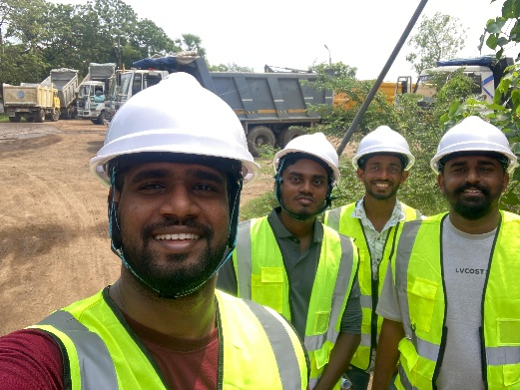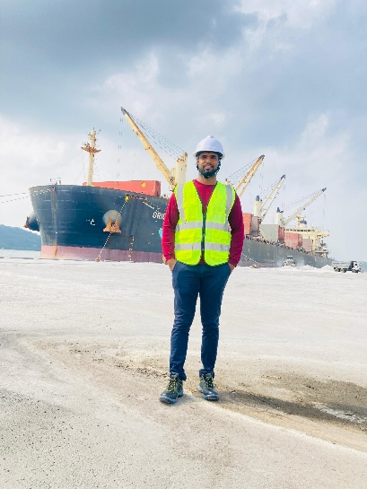

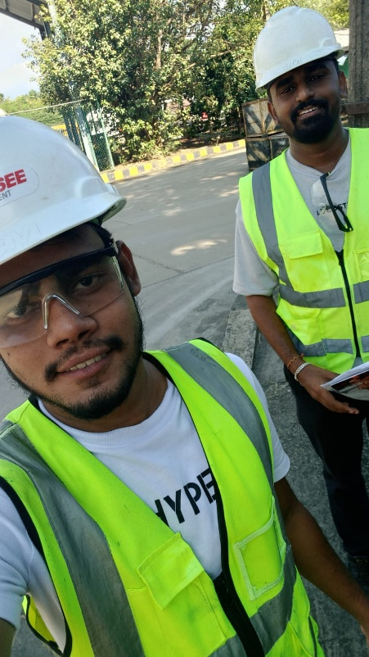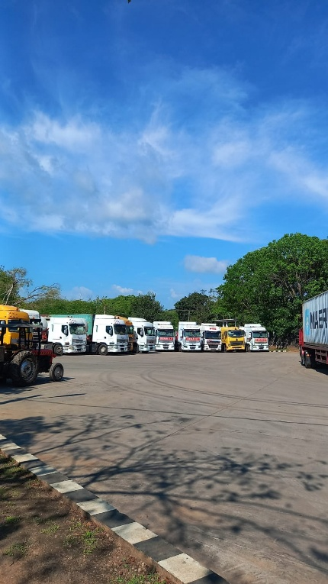

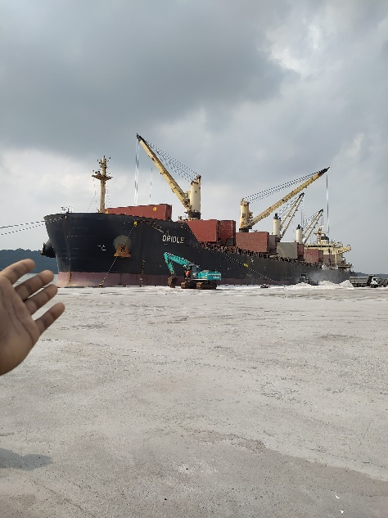

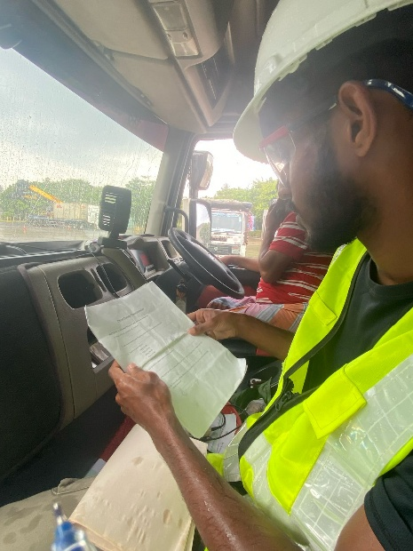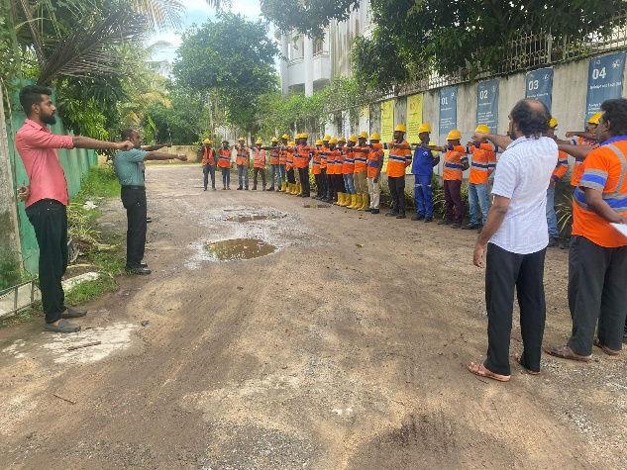

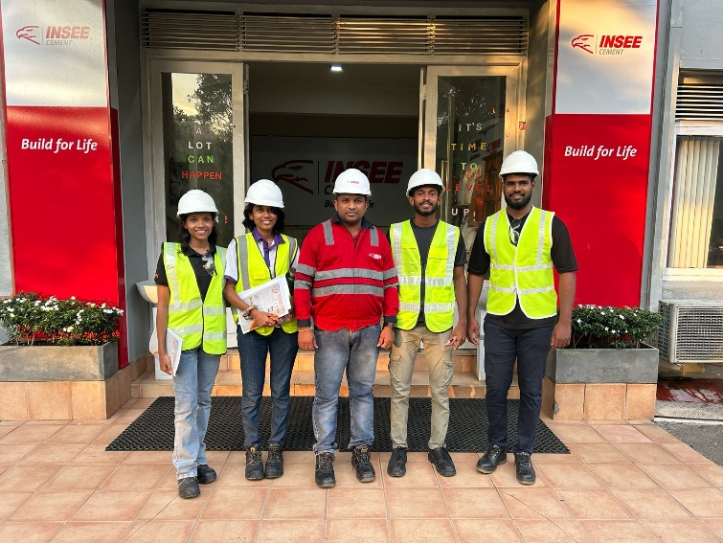

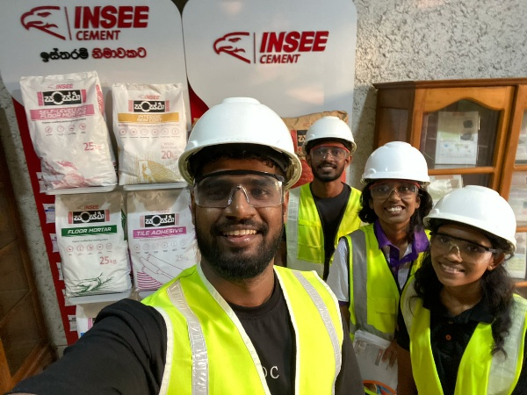

* Hard copies of the questionnaire were brought for the surveys, and face-to-face interviews with drivers were conductedWe asked the questions verbally and wrote down their answers in a notebook during the conversation.
* There were inbound and outbound were included to this survey to get a balanced view.
* A chance to participate was provided to all available drivers during the visits.
* Data Entry
* After the answers were collected, the information was organized into Microsoft Excel.
* The answers were grouped into categories and variables to help with analysis and report writing later.
* Data Tools and Accuracy
* Tools Used
* Data was entered and organized using **Excel**
* Basic statistics were run and patterns were identified using **SPSS**.
* Graphs and visuals were created using **Python**.
* Data Quality
* To avoid mistakes, data entries were double checked.
* If unclear answers were found, they were flagged for review before analysis was started.

**Sample Selection**

This study was focused on the driver workforce of INSEE Cement Sri Lanka, which is made up of more than 800 drivers across the country. The researcher used random sampling to select participants for the study in order to establish fairness as well as eliminate biases from the research.

A total of 150 drivers were randomly selected. This number was chosen because it was considered manageable by the team and still large enough to represent the overall driver population. On site observations and one to one interviews were conducted with those selected drivers. The data that was collected focused on their behavior, vehicle-related issues, and adherence to company safety protocols.

Two main types were identified among this drivers: inbound drivers (who bring raw materials to the plants) and outbound drivers (who deliver finished cement products). All of the drivers under these two categories were included to ensure a broader understanding of the different challenges faced in their daily operations.

To make the study more comprehensive, several INSEE Cement plants and warehouses across the country were visited. These included locations in Trincomalee, Galle, Kadawatha, Kelaniya, Katunayake, Piliyandala, and Puttalam. There were drivers who follows different routes and regions. Through the use of this random and diverse sampling approach, more accurate, balanced, and meaningful insights were gathered about the real-life experiences of INSEE Cement’s driver workforce.

**Ethics and Bias Control**

* Confidentiality
* Data were collected anonymously. Therefore no one can identify form the survey details
* Because of that drivers were helped to feel safe in giving honest answers.
* Reducing Bias
* It was explained to them that we were students, not company staff.
* The interviews were kept friendly and respectful to make drivers feel comfortable.
* Participation was voluntary, and no one was forced to take part.
* Timeline
* The surveys were done over a two-month period.
* Visits were made at different times of the day to observe different driver routines and levels of tiredness.

**Study Limitations**

1. Honesty of Responses - It might not be admitted by some drivers that they feel tired or break rules.
2. Limited Time – There were tow months time period to collect data. Therefore it doesn’t represent the full picture of year round.
3. Availability - Only the drivers who were on-site during our visits were included.

Summary of the Process

| Step | Description |
| --- | --- |
| Questionnaire Design | Used Printed surveys with multiple choice questions, reviewed by company experts |
| Distribution | Asked questions and noted down through face-to-face interviews |
| Data Recording | Used notebooks to write answers and later entered into Excel |
| Sampling | Randomly selected 150 drivers across different roles and locations |
| Ethics | Responses recorded anonymously and voluntary participation |
| Analysis Tools | Excel , SPSS, Python |

Real and reliable data were collected from the drivers using this approach, while keeping the process simple and respectful. To make the process more efficient, digital surveys or monitoring tools could be used.

**Sections**

**Data Collection Techniques**

To collect the data, a structured questionnaire was designed and used. Driver behavior, safety knowledge, work conditions, and vehicle maintenance were mainly focused through the questionnaire. The surveys were done through face-to-face interviews with drivers at different INSEE Cement sites. To make the process consistency, each participant answered to the same set of questions.

**Equipment Used**

* Printed questionnaires - for collecting answers.
* Notebooks and pens - to writing down responses during interviews.
* Microsoft Excel - to enter and organize data.
* SPSS software - to statistical analysis and drawing charts.
* Python - for create charts and graphs for better data visualization.

**Experimental Design**

A random sampling method was followed in the research. Out of over 800 drivers in the company’s logistics network, 150 drivers were randomly selected. Inbound (bringing raw materials) and outbound (delivering cement) drivers were included. This helped balanced results to be obtained from different driving roles and regions.

**Data Recording, Summarizing, and Analysis**

* All answers were written down during interviews.
* Responses were then categorized in to some variables and entered into Excel sheets.
* SPSS and Python was used to create charts such as bar graphs, pie charts, and box plots to clearly show the results.
* Data was reviewed carefully to avoid errors, and unclear responses were double checked

**Results**

The section presents the results obtained from surveys and interviews with drivers employed at INSEE Cement. The data presentation includes clear charts together with graphs to help readers understand complex information. The visuals display crucial behavioral and safety trends regarding drivers and their perceptions about tiredness together with their workplace experiences. The evaluation provides vital knowledge about driver obstacles while showing potential opportunities for improvement. Satisfaction Levels by Work life balance

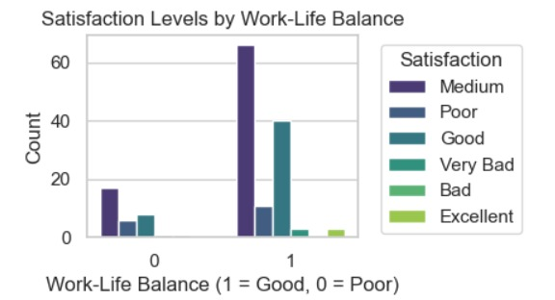

The chart presents driver opinions on the work-life balance and how adequate vacation time affects their ability to handle family responsibilities. The data shows that drivers with good work-life balance (marked as 1) expressed medium through good satisfaction levels based on the chart. The positive assessment appears as some respondents assigned the highest rating of excellent. Drivers whose work-life balance was rated as poor (marked as 0) primarily stated their satisfaction as medium or poor or very bad or bad. Work-life balance demonstrates substantial influence over the satisfaction levels of drivers. Drivers who receive enough vacation to deal with their personal and family needs show greater job satisfaction. Revision of employee vacation programs represents an opportunity to enhance both driver sentiment and occupational welfare.

* Vehicle Issue Rate by Satisfaction Level

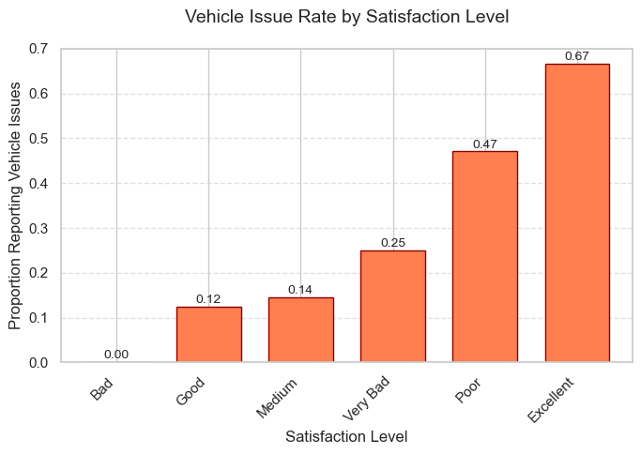

This chart shows a bit of an unexpected trend drivers who say they’re highly satisfied (like "Excellent") and drivers who say they are poor satisfied are mostly likely to report vehicle issues than those who aren’t. Drivers who satisfied about their job are more likely to report problems more responsibly and drivers who unsatisfied about their job might ignore or underreport issues.

* Work Hours Vs Satisfaction Level

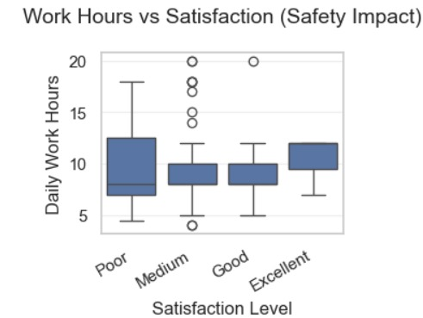

This boxplot shows how the daily working hours of drivers vary based on their satisfaction levels. The satisfaction level of each driver (like Poor, Medium, Good, Excellent) is shown with a box, which helps us understand the spread of working hours in each group.

From the chart, we can see that drivers with lower satisfaction levels (such as “Poor” and “Very Bad”) tend to work longer hours, while those with higher satisfaction (such as “Good” and “Excellent”) usually work fewer hours. This shows a clear link between satisfaction and workload.

In each box:

* The middle line shows the median, which is the middle value of working hours in that group.
* The top and bottom edges of the box show the 25th and 75th percentiles. This means that half of the drivers in that group worked within that range of hours.
* The lines outside the box show the lowest and highest working hours, excluding outliers.
* Any dots outside the whiskers are outliers, which are drivers who worked much more or less than others in their group.
* Poor Satisfaction: The working hours are the highest in this group. The box is tall and goes from around 10 to more than 15 hours. The median is also high, showing that most drivers here work long days. This group also has a few outliers who work even longer.
* Medium Satisfaction: The working hours are a bit lower compared to “Poor”, but still higher than the “Good” and “Excellent” groups. The box is smaller, meaning the working hours are a bit more consistent.
* Good and Excellent Satisfaction: These two groups have the lowest and most consistent working hours. Most drivers here work between 8 to 10 hours per day, and there are very few outliers. This shows that more satisfied drivers usually have better work-life balance.

This boxplot clearly shows that satisfaction is connected to working hours. Drivers who have normal or balanced working hours are more satisfied than who has very long working hours. This finding is important for the company because it highlights the need to manage work schedules better to improve driver well-being and job satisfaction.

* Most Optimum Driving Time In The Day

|  |  |  |  |  |  |
| --- | --- | --- | --- | --- | --- |
|  | | | | | |
|  | | Frequency | Percent | Valid Percent | Cumulative Percent |
| Valid |  | 2 | 1.3 | 1.3 | 1.3 |
| afternoon | 4 | 2.6 | 2.6 | 3.8 |
| anytime | 12 | 7.7 | 7.7 | 11.5 |
| early morning & night | 11 | 7.1 | 7.1 | 18.6 |
| night | 127 | 81.4 | 81.4 | 100.0 |
| Total | 156 | 100.0 | 100.0 |  |

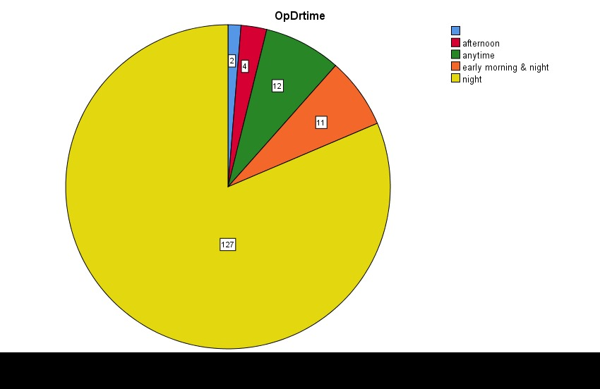

This pie chart represent the preferred driving time of day for a group of drivers. The chart helps us understand when most drivers feel comfortable or prefer to be on the road. The total number of responses is 156, based on the numbers shown in the chart.

Summary of Results:

* Night (127 drivers): The majority of drivers about 81% prefer driving at night. This is a clear preference and takes up the biggest part of the pie chart.
* Early Morning & Night (11 drivers): About 7% of drivers said they like to drive both in the early morning and at night.
* Anytime (12 drivers): Roughly 8% of drivers are flexible and said they are comfortable driving at any time of the day.
* Afternoon (4 drivers): Only about 2.5% of drivers prefer the afternoon for driving.
* No answer (2 drivers): A small group (around 1%) didn’t give a preferred time.

According to this chart Four out of Five drivers were selected the night as the most preferred time to drive. This may be because night driving offers less traffic, cooler weather, or a more relaxed environment. A smaller group likes the combination of early morning and night, which might be for similar reasons.

Only a small number of drivers prefer the afternoon, which could be due to high traffic, heat, or other responsibilities during that time. The group of drivers that can drive "anytime" likely has fewer restrictions or is more comfortable with all driving conditions.

Nighttime is clearly the most favored driving period among this group of drivers. The chart shows that most drivers feel safer, more relaxed, or find it easier to drive at night. The data could help in planning services, road maintenance, or delivery schedules by aligning them with drivers' preferred times.

* Most Worst Driving Time In The Day

|  |  |  |  |  |  |
| --- | --- | --- | --- | --- | --- |
| **BadDrtime** | | | | | |
|  | | Frequency | Percent | Valid Percent | Cumulative Percent |
| Valid |  | 20 | 12.8 | 12.8 | 12.8 |
| day time | 39 | 25.0 | 25.0 | 37.8 |
| morning | 3 | 1.9 | 1.9 | 39.7 |
| night | 2 | 1.3 | 1.3 | 41.0 |
| none | 1 | .6 | .6 | 41.7 |
| office time | 49 | 31.4 | 31.4 | 73.1 |
| school time | 42 | 26.9 | 26.9 | 100.0 |
| Total | 156 | 100.0 | 100.0 |  |

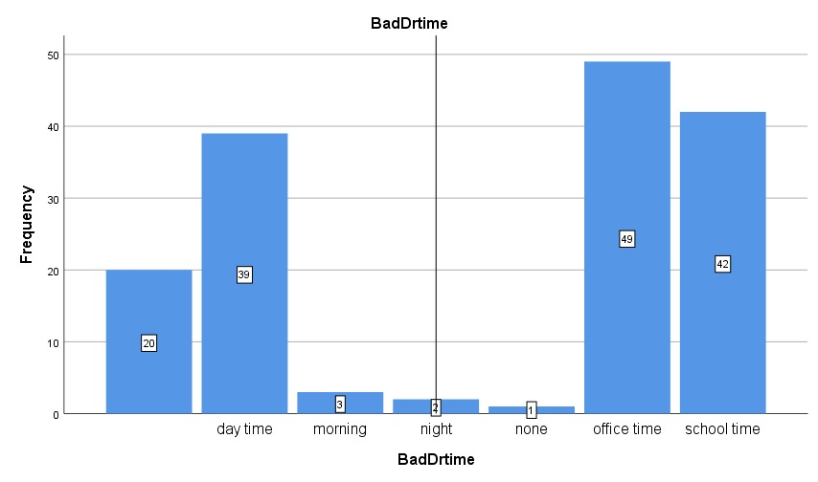

The worst times of the day to drive, based on opinions from a group of drivers aer shows in this bar graph. It reflects the times when people feel most uncomfortable, stressed, or unsafe while driving.

The x-axis shows different times of day (like day time, morning, night, office time, etc.), and the y-axis shows how many drivers picked each time as the worst.

* Office time (49 drivers): This is the most commonly selected worst driving time. Usually around 8 – 10 AM and 4 – 6 PM period drivers were found more stressful, likely due to heavy traffic and rush hour pressure.
* School time (42 drivers): A large number of drivers also dislike driving during school hours. This might be because of traffic congestion, school zones, and more pedestrians on the road.
* Day time (39 drivers): Some drivers said daytime in general is not ideal, possibly due to heat, glare from the sun, or busy roads.
* Night (2 drivers), Morning (3 drivers): Only a small number of drivers chose these times as the worst. This might mean these times are generally calmer or preferred by many.
* None (1 driver): One person did not pick any time as the worst, possibly because they feel comfortable driving anytime.

The chart shows that office time and school time are the two most disliked driving periods, with 49 and 42 drivers selecting them, respectively. These times are typically the busiest hours on the road, with a lot of movement from workers and students, causing traffic jams, delays, and stress.

Only a few drivers reported that morning or night driving is bad, suggesting those times are quieter and less problematic for most people.

Most drivers feel that rush hours (office and school times) are the worst for driving, mainly due to traffic congestion and higher risks of accidents. This data could help city planners, traffic control authorities, and delivery services to avoid these times or improve road conditions during them. It also supports the idea that avoiding peak hours can lead to a safer and smoother driving experience.

* Techniques to avoid Stress and Sleepiness

This bar chart represent the different strategies people use to avoid stress or sleepiness while driving. The most common response by far is “Rest”, with over 70 people choosing it. This shows that most individuals prefer to take a break or rest when they start feeling tired or stressed, which is a passive and easy method of recovery.

Other frequently mentioned strategies include “Eating” (about 30 responses) and “Smoking” (around 22 responses). These are also common ways people try to stay alert, suggesting that drivers often turn to familiar or convenient habits to stay focused.

On the other end, strategies like “chewing,” “drinking tea,” “sleep,” “singing,” and “washing face” were chosen by very few people mostly fewer than 5. These actions are less popular, possibly because they are harder to do while driving or not seen as effective.

* Most people seem to prefer passive strategies like resting or eating over more active or unusual ones.
* The fact that rest is the most used method shows it’s likely considered the safest, most accessible, and effective way to deal with drowsiness or stress.
* A screenshot of a report

  AI-generated content may be incorrect.Vehicle Conditions and Safety Features
* A screenshot of a survey

  AI-generated content may be incorrect.Work Environment and Issues
* A close-up of a document

  AI-generated content may be incorrect.Vehicle Issues

**Discussion**

The study found a clear negative connection between the number of hours worked and driver satisfaction. Drivers who worked shifts longer than 15 hours reported much lower satisfaction levels, ranging from Poor to Medium. In contrast, those working between 5 to 10 hours reported satisfaction levels ranging from Good to Excellent.

* Work-life balance was identified as an important factor - drivers who reported poor balance (0) were three times more likely to rate their satisfaction as Very Bad.
* Implication - The current scheduling practices at INSEE may unintentionally increase the risk of accidents and staff turnover. Implementing shift limits (no longer than 12 hours) and offering more flexible schedules (such as avoiding peak traffic times during school hours) could help reduce these risks.

**Vehicle Maintenance and Safety**

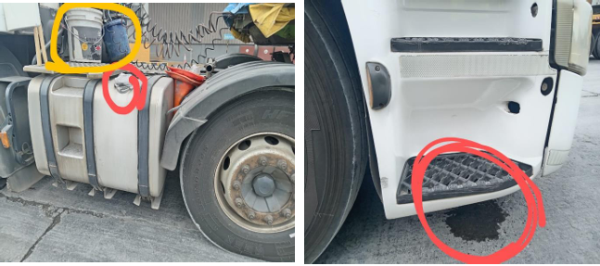

While basic safety features, such as horns and brakes, showed high levels of compliance, Also there were several critical gaps:

* Lights and tire indicators had a non - compliance rate of 22–25%, which poses risks when driving at night or on rainy days.
* While 85.9% of vehicles had seatbelts available, only 98.1% of seatbelts were functional, suggesting that about 14% of vehicles did not have seatbelt installations at all.
* Mechanical issues like overloading and air leaks were recurring problems.
* Behavioral Gap: Only 75% of drivers maintained a safe distance from other vehicles, pointing to possible gaps in training.

**Sources of Error and Limitations**

* **Data Collection Biases**
* The drivers appeared to underrate their fatigue and violations like speeding since they anticipated negative job consequences from revealing such information.
* Sample selection during the survey visits exclusively included drivers who remained present during the schedule because long-haul operators and sick workers were excluded from participation.
* **Methodological Constraints**
* The lack of Telematics devices in manual surveys prevented measurements of actual driving speeds and compared them with recorded speeds.
* The study measured satisfaction as reported subjective data instead of employing standardized rating scales that employed validated Likert scales..

**Future Research Recommendations**

* **Short-Term Priorities (1–2 Years)**
* **IoT-Enabled Monitoring**:
  + 1. The deployment of real-time fatigue sensors (including steering grip analysis) should occur in fifty vehicles.
    2. Expected Outcome: A 20% reduction in fatigue-related incidents.
* **Longitudinal Satisfaction Tracking**:
  + The company will conduct surveys about policy changes every quarter to measure their effects after installing shift caps.

**Stress and Operational Timing**

Morning and school times created high stress for drivers as they preferred nighttime routes because of their lower traffic volumes.

* Congestion (e.g., Piliyandala-Kadawatha routes).

A large number of drivers managed their stress through smoking cigarettes (14%) while dominating through chewing tobacco as their most common method although this suggested inadequate rest periods.

**Broader Implications for Industry and Policy**

* **Logistics Efficiency**
* The solution to address overloading and air leak issues would generate cost savings through breakdown delay reduction estimated at 15% based on current breakdown frequency rates.
* The improvement in safety performance might help INSEE obtain better insurance terms in addition to strengthening its image in the market.
* **Alignment with Global Standards**
* V2V protocols enable the testing of Smart City technology through INSEE fleet operations to decrease risks from traffic congestion.

**Conclusion**

This study revealed that working conditions affect driver satisfaction together with road safety performance because drivers assess their capabilities through daily work hours and rest opportunities. Overworked drivers face elevated risks of being unpleased with work as well as feeling stressed and fatigued which results in both careless driving behavior and less performances.

Most drivers prefer to drive at night because it is calmer and less crowded, while they struggle during office and school hours due to high traffic and stress. Rest is the most common way drivers deal with tiredness, but the use of smoking and eating as coping methods also shows the need for better health support.

INSEE Cement can reduce risks and improve the well-being of its logistics team, by improving work schedules, giving more vacation time, providing better vehicle maintenance, and raising awareness about safe driving habits. Making these changes will not only help protect the drivers but also strengthen the company’s overall delivery system.

**References**

INSEE Cement Sri Lanka. (n.d.). *Home*. [online] Available at:

<https://www.siamcitycement.com/srilanka/en/home> [Accessed 22 Apr. 2025].

**Annexure**

Data Set -<https://drive.google.com/file/d/1Z3sVhfu7uSy00hpjjXi6kN_GATmq4yz7/view?usp=sharing>

Python Code –

<https://drive.google.com/file/d/1B8gqUEZ6CPcPfQzkGFUkHqy2hjf9d83w/view?usp=sharing>

Driver Survey Questionnaire –

<https://docs.google.com/document/d/1Fvoa23Nlw32e6lXiNTNXK_xQ3KXqFrfj/edit?usp=sharing&ouid=109003143648734420374&rtpof=true&sd=true>